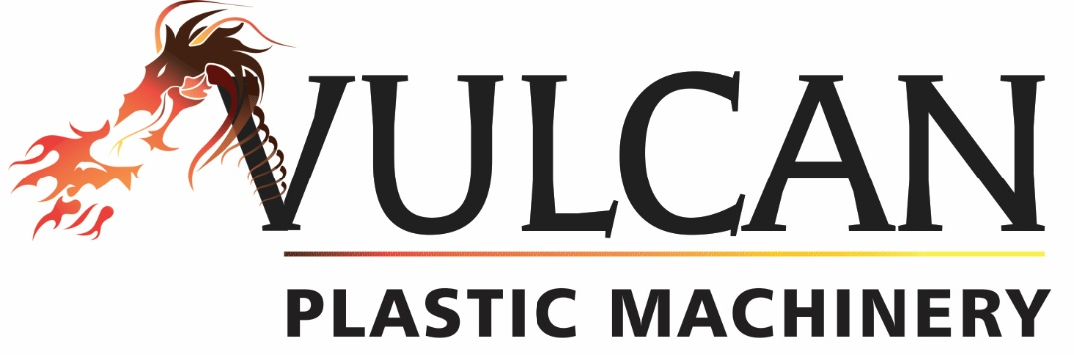

Two-Year Limited Warranty

Vulcan Plastic Machinery warrants that its material handling equipment, under normal and proper use, shall be free from defects in material and workmanship that impair its usefulness for a period or two (2) years from date of shipment. The seller’s obligation under this warranty is limited to repairing or replacing, at their option, any defective parts. Components and parts that wear or that are damaged by misuse are not warranted. No on-site service is available unless prepaid by the customer. Defective equipment must be returned to Vulcan Plastic Machinery in El Paso, TX at buyer’s expense, and prior authorization for return is required.

Limitation of Liability

In no event shall Vulcan Plastic Machinery be liable for special, indirect, incidental, or consequential damages, whether in contract, tort, negligence, strict liability or otherwise, including without limitation damages for injury to person or property, lost revenue or profits, lost sales or loss arising from or pertaining to use of any Products. Buyer’s sole and exclusive remedy against Vulcan Plastic Machinery shall be the repair or replacement of defective parts as provided herein. Vulcan Plastic Machinery’s liability on any claim, whether in contracts, tort, negligence, strict liability or otherwise, for any loss or damage arising out of or in connection with Buyer’s order, shall in no case exceed the purchase price of the Products actually paid to Vulcan Plastic Machinery by the Buyer.

